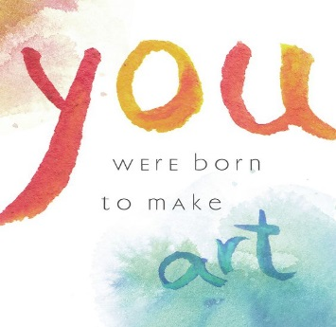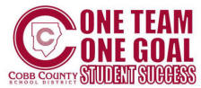

**STUDIO ASSIGNMENTS:**

Daily class participation Collaborative projects

Edmodo reflections

Digital portfolio

**TESTING:**

Formative Assessment - August

4 week quiz/9 week TEST

Semester Summative Assessment

**INSTRUCTIONAL WORKBOOK:**

Each student will keep a notebook in the artroom. It will contain written responses, vocabulary lists and other items relating to each art assignment.

**SUPPLY LIST:**

Folder notebook with paper

6 #2 pencils

2 white erasers

2 Sharpies (Black fine point)

Handheld sharpener

1 box Crayola colored pencils

1 set of Prang Watercolors (all can be found at Wal Mart)

In his best-selling book, **A Whole New Mind: Why Right-Brainers Will Rule the Future**, Daniel Pink writes: “The future belongs to a different kind of person with a different kind of mind: artists, inventors, storytellers—creative and holistic “right-brain” thinkers whose abilities mark the fault line between who gets ahead and who doesn’t.” Pink goes on to write that art is the single most important class that students can take because the art class is one of the few places in school where creativity is taught. Why does middle-level art matter? Learning and innovation skills will help to ensure that our students are prepared for increasingly complex life and work environments in the 21st century. According to the Partnership for 21st Century Skills (www.21stcenturyskills.org), these skills include creativity and innovation, critical thinking and problem-solving, and communication and collaboration.

“Points to Ponder” ☺

**“ATTITUDE IS EVERTHING”**

The 2016-17 School year is going to be an ***Outstanding*** year at TAPP Middle! Come to class prepared with a desire to learn and create every day! There are no FREE days-every day is a chance to learn something new about the world around you-being in my class means LEARNING something new!

In this class you will:

* Generate and conceptualize artistic ideas and work
* Develop organizational skills, to include supplies, works of art and assignments
* Learn to critique works of art, evaluate works according to a rubric, and participate in group critiques
* Understand how the arts enriches the community and the world
* Appreciate art influences and styles throughout the world

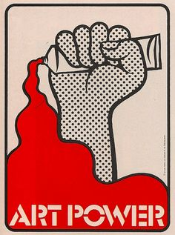

Cell: (913) 707-6307 School

Phone: (770) 222-3758

Planning Period:



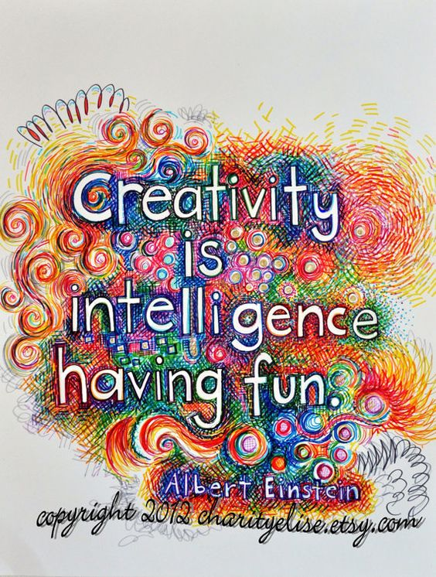

WELCOME TO ART

DR. REBECCA POOL, INSTRUCTOR

Email: [Rebecca.pool@cobbk12.org](mailto:Rebecca.pool@cobbk12.org)

**A LITTLE NOTE ABOUT YOUR INSTRUCTOR:**

Dr. Pool is from Overland Park, KS, a suburb of Kansas City. She received a BFA in Commercial Art from UCM, a Masters in Educational Leadership from Baker University and a PhD in Curriculum and Instruction from Capella University. A previous owner of Gregg and Assoc Advertising in KC, she is married to Jim Pool. They have two grown children, Kate and Adam who live in KC. They are also proud pup parents to Dewey (Jack Russell terrier) and Pippin (Italian Greyhound).



**GRADING**

Each assignment will be graded according to a rubric provided at the beginning of each project, along with self-assessments and group assessments as required. Grades will be accessible in the gradebook at the completion of each project. Special emphasis will be placed on the following:

* Class behavior, manners and care of supplies
* Critical thinking skills and focus on work
* An ability to engage and persist through the creative process
* Class discussion participation



TAPP MS ART STUDIO NOTES 2016-17